HTB 2019-2020 SEASON OVERVIEW

TRYOUT REGISTRATION – Sunday, Sept 15th & Sunday, Sept 22nd @ HHS
ALL players must preregister at www.haverhilltravelbasketball.org
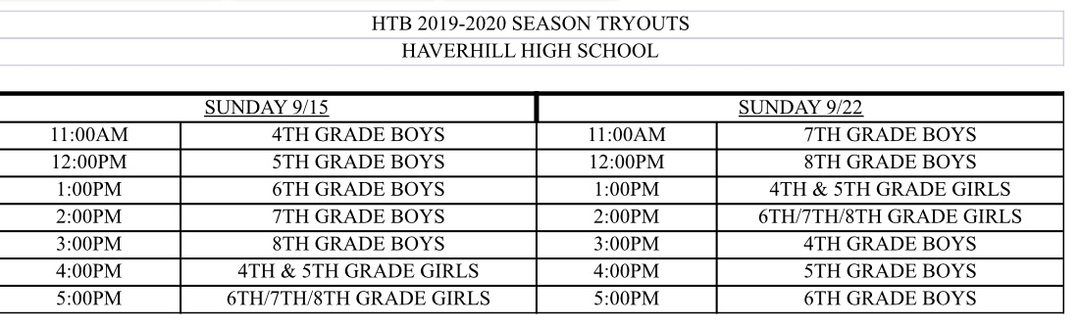
2019-2020 REGISTRATION FEE - $350
Includes 2 practices/week, 2 Regional Tournament Team Entries, 15-20 Regular Season Games, NEW Team Uniforms & Practice Jersey
Financial Aid Application available on our website
IMPORTANT DATES
- TRYOUTS – SUN 9/15 & SUN 9/22
- TEAMS & PRACTICE SCHEDULE ANNOUNCED – MON 10/7
- MANDATORY PARENTS MEETING – TUES 10/15
- PRACTICES BEGIN – MON 10/21 (EACH TEAM HAS 2 PRACTICES/WEEK)
- HTB FALL TAG DAY – SAT 11/2 & SUN 11/3
- THANKSGIVING TOURNEY – FRI 11/29, SAT 11/30 & SUN 12/1
- 1ST WEEK OF DECEMBER – REGULAR SEASON BEGINS
- HTB NIGHT @ CELTICS – TBD
  - TICKETS ON SALE 11/1/19
- HOOP A THON & TEAM PICTURES – SUN 1/12/20
- HTB FUNDRAISER – FRI 2/7/20
- 1ST WEEK OF MARCH – RIVER VALLEY PLAYOFFS
- 2ND WEEK OF MARCH – MERRIMACK VALLEY LEAGUE PLAYOFFS
- END OF SEASON BANQUET – FRI 3/20
- HTB SPRING TAG DAY – APRIL 2020 (DATE TBD)

FOLLOW US FOR UP TO DATE ANNOUNCEMENTS:

 @HaverhillTravelBasketball haverhilltravelbasketball  @HaverhillBBall
This Photo by Unknown Author is licensed under CC BY-SA
This Photo by Unknown Author is licensed under CC BY-SA-NC
This Photo by Unknown Author is licensed under CC BY

