Nettle News 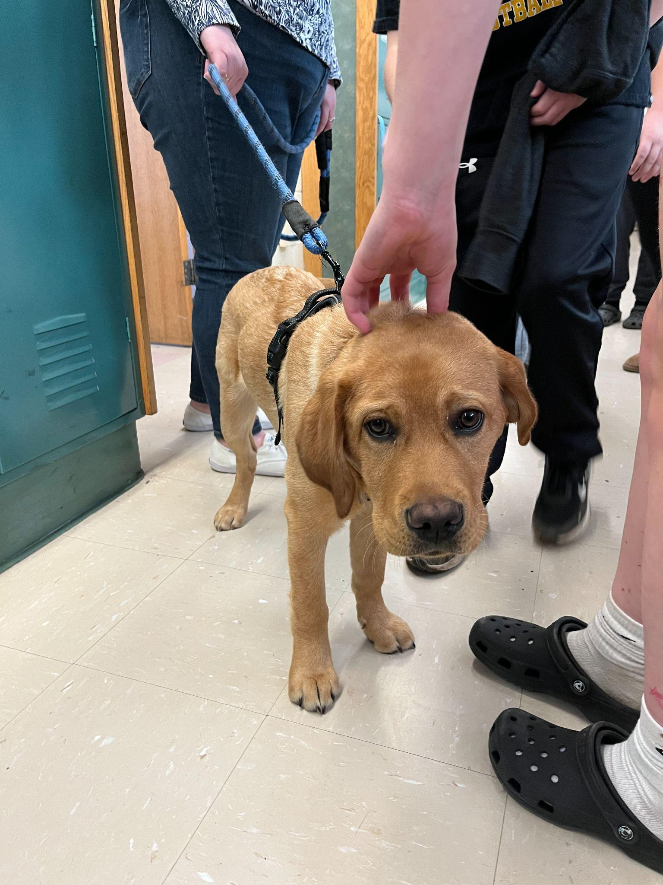
Nettle Middle School… Community School for EVERYONE, June 8, 2025

Important Dates
Monday, June 9
Promotion Ceremony and Dance (5:00 for families)
Tuesday, June 10
Field Day grade 6 and 7
Wednesday, June 11
Field Day grades 5 and 8
Thursday, June 12
Last day of school Early release day

First day of school
Tuesday, August 26, 2025

Message from the Principal
The promotion ceremony for grade 8 will happen on Monday, June 9, 2025. The ceremony will take place on the back field beginning at 5:00 pm. Grade 8 students will need to arrive at school at 4:00. Please bring folding chairs to use in the backfield as we will not have seating for families. If you are bringing balloons or using a sun umbrella - please make sure you are standing at the back so that you do not block anyone’s view of the event.
I have enjoyed being your principal, assistant principal, and math teacher over the past 14 years. I look forward to seeing you all at the Consentino/Nettle Soccer, Basketball and Volleyball games!

Enjoy your summer!

Your next Nettle News will come from Mr. Perez

ELA
See the Summer Reading List attached

Thank you to our Trimester 2 Good Citizens Club for creating a mural and our Trimester 3 Good Citizens Club for planting flowers!

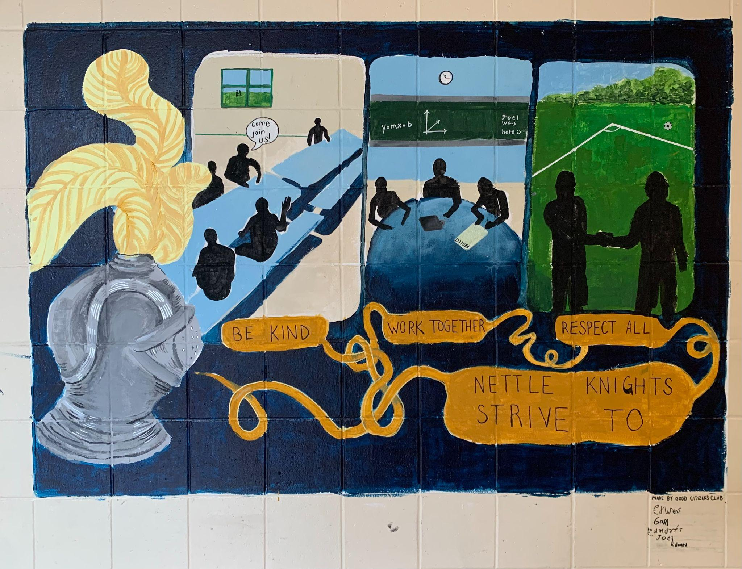

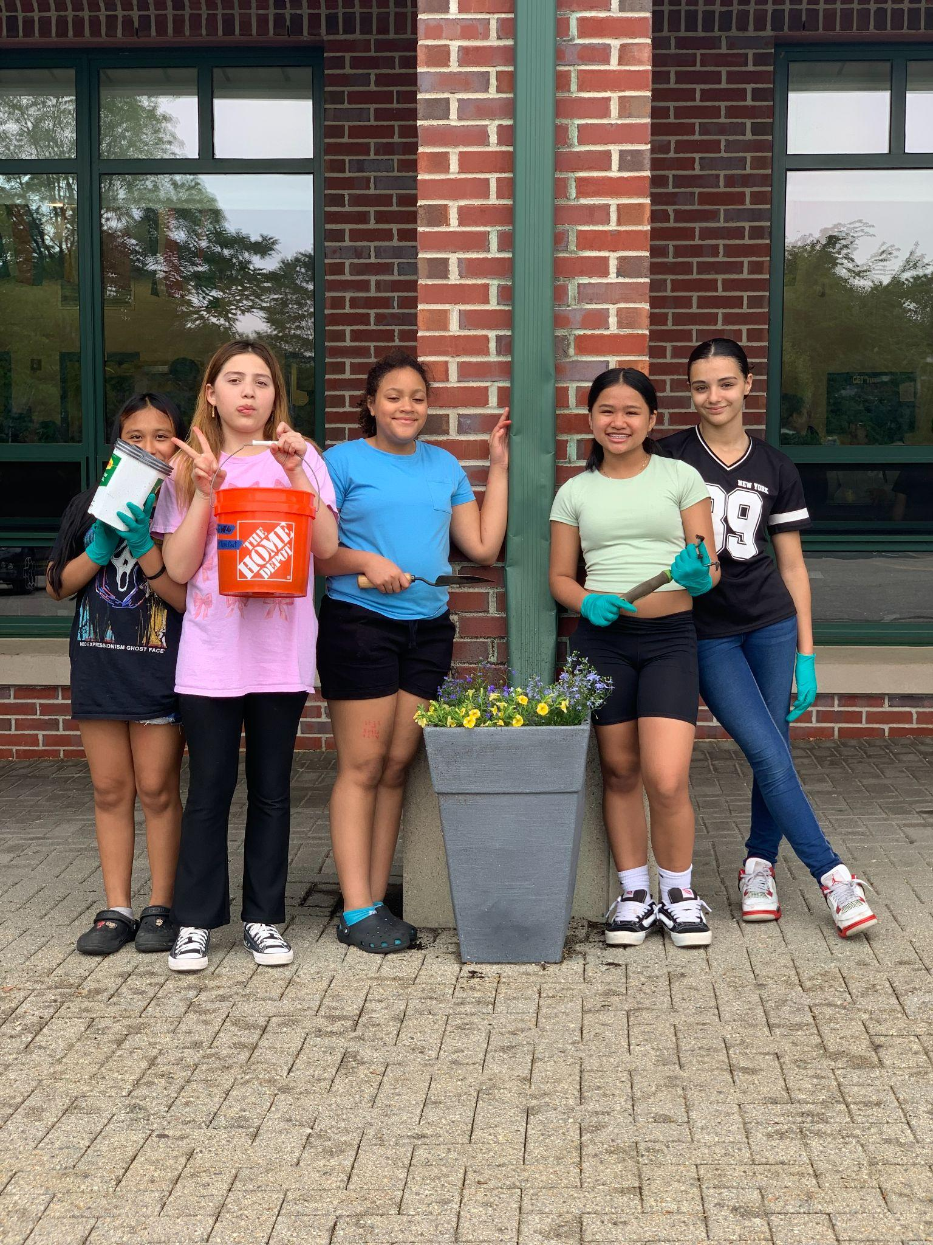

A big thank you to our community partners Fantini Bakery, Valley Logistics, 411 CARES, The Barber Academy, Gourmet Specialty Foods, Bloom by Nancy, Firehouse Center of the Arts, Riverside Church, Union Installations, and Crystal Engineering
Please continue checking the Nettle Middle School website for updates. nettle.haverhill-ps.org
Contact Eileen Doherty at eileen.doherty@haverhill-ps.org.

